;

**LAB 4:**

**PLC Interfacing with Microcontrollers and PCs over Ethernet/IP: Understanding both software and hardware aspects of PLC interfacing**

**MCTA 3202**

GROUP F

GROUP MEMBERS MATRIC NO

1. Muhammad Naufal bin Mohammad Bakri 2110333
2. Muhammad Khairul Aiman bin Mohamad Basari 2113571
3. Muhammad Nabil Ikhmal Bin Khairil Rizal 2114577
4. Muhammad Zakwan Zikri bin Irwan Affandi 2111033
5. Che Muhammad Danial Bin Che Suhaimi 2119075

DATE OF SUBMISSION :

15th November 2023

## **Table of Contents**

| **CONTENT** | **PAGE** | **REMARK** |
| --- | --- | --- |
| ABSTRACT | 3 |  |
| INTRODUCTION | 3 |  |
| MATERIALS AND EQUIPMENT | 4 |  |
| EXPERIMENTAL SETUP | 4 |  |
| METHODOLOGY | 5 |  |
| DATA COLLECTION | 5 |  |
| DATA ANALYSIS | 6 |  |
| RESULTS | 7 |  |
| DISCUSSION | 8 |  |
| CONCLUSION | 8 |  |
| RECOMMENDATIONS | 9 |  |
| REFERENCES | 10 |  |
| APPENDICES | 10 |  |

## 

## **Abstract**

This report presents the design and implementation of a start and stop control circuit for an LED using ladder logic and OpenPLC software. The circuit was simulated and tested on an Arduino board with two push buttons, a resistor, and an LED. The report explains the background and theory of PLCs, ladder logic, and OpenPLC, and describes the materials, equipment, methodology, data collection, and data analysis of the experiment. The report also discusses the results, conclusion, and recommendations of the experiment, highlighting the advantages and challenges of using OpenPLC for industrial automation applications. The report includes code snippets, a circuit diagram, and a student’s declaration.

## **Introduction**

### Overview of the experiment's purpose and objectives

The objective of this experiment was to design and implement a start and stop control circuit for an LED using ladder logic. The primary goal was to demonstrate the basic principles of relay logic and ladder diagrams in industrial automation, specifically for controlling an LED with start and stop buttons.

### Background information and relevant theory or concepts

A Programmable Logic Controller (PLC) is an industrial computing device designed for automating and controlling electromechanical processes. PLCs are programmable and operate in real-time, interfacing with sensors and actuators to manage inputs and outputs in industrial environments. They are known for their reliability, modularity, and communication capabilities, making them essential components in industrial automation systems. PLCs are commonly used in manufacturing, energy, and various industries, where they execute control functions based on programmed logic to regulate and optimize processes. The programming of PLCs is often done using ladder logic, a graphical language that simplifies the representation of control logic through intuitive diagrams.

OpenPLC is an open-source initiative offering both software and a community-driven platform for Programmable Logic Controllers (PLCs), aiming to make industrial automation more accessible. The project provides freely available tools that allow users to program, simulate, and experiment with PLCs on standard computer hardware. OpenPLC supports modularity, enabling users to customize their control systems, and its simulation capabilities facilitate testing and debugging in a virtual environment before actual deployment. With a focus on compatibility and education, OpenPLC serves as a valuable resource for individuals and institutions interested in learning and developing industrial automation applications while fostering collaboration and innovation within the automation community.

## **Materials and Equipment**

* OpenPLC Editor software
* Arduino Board
* 2 Push Button Switches
* Jumper Wires
* LED
* Resistors
* Breadboard

## **Experimental Setup**

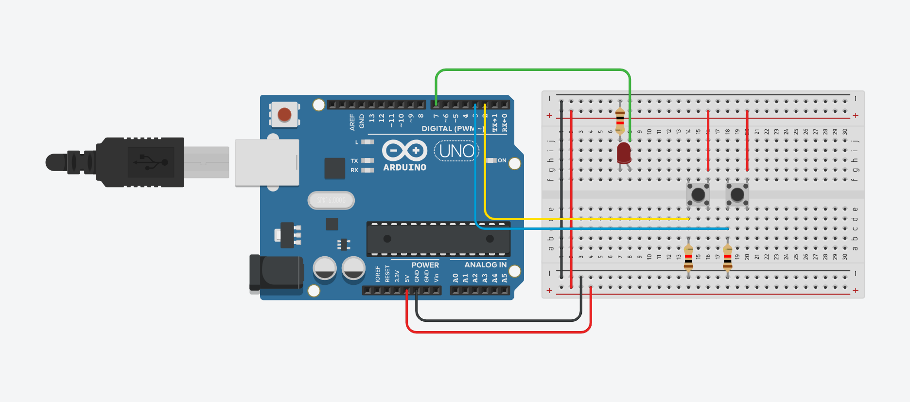

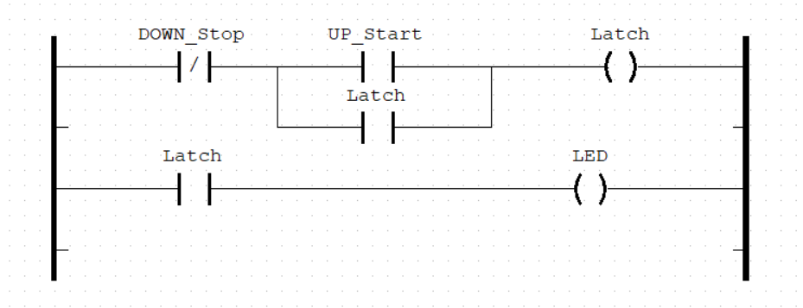

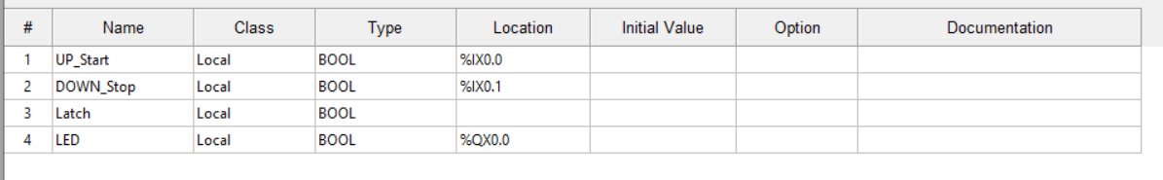

## **Methodology**

1. The ladder diagram shown in Fig. 5 is created.
2. All variables used in the ladder diagram are to be specified.
3. The ladder diagram is compiled and simulated in OpenPLC Editor.
4. The ladder diagram is uploaded to the Arduino board.
5. The correct COM port number and all pin associations between the OpenPLC variables and Arduino board are to be selected.
6. The circuit as shown in the experimental setup is built.
7. The functionality is tested.

## **Data Collection**

During the process of doing this experiment, we learn that the physical addressing for input and output pin is differ for each type of microcontroller use.Physical addressing often refers to the identification and control of specific hardware components connected to the microcontroller.

Since we are using Arduino Mega as the microcontroller,the physical addressing that we used are as follow:-

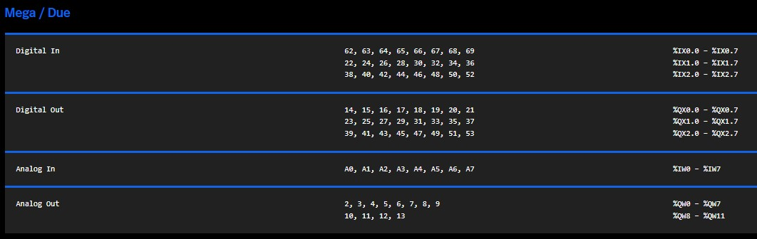

## 

## **Data Analysis**



The Start-Stop control circuit in a ladder diagram consists of a power supply with two rungs.

As the DOWN_Stop is normally closed, it will let the current flow as long as the button assigned for it has not been pushed. After that, there's two junctions, one is UP_Start and one is Latch. As soon as the button assigned for UP_Start is pressed, it will let the current from DOWN_Stop to flow through the UP_Start normally open input and triggering the Latch output and input. When the Latch output is 1, it will act as a latch to keep the current to flow, and make both Latch inputs high. The Latch input will then send the high signal to the LED output, so that it will be turned on.

When the DOWN_Stop is pressed, it will break the current flow from start, making everything low again, and turning off all of the subsequent inputs and outputs, hence turning off the LED.

## 

## **Results**

The result of the experiment was a successfully implemented start and stop control circuit. When the start button was pressed, the LED lit up even after releasing the button, thanks to the holding contact (latch). Pressing the stop button halted the LED by de-energizing the relay coil.

<https://github.com/NotLafuan/GROUP-F-MCTA-3203/raw/main/Week%205/Group%20F%20Week%205.mp4>

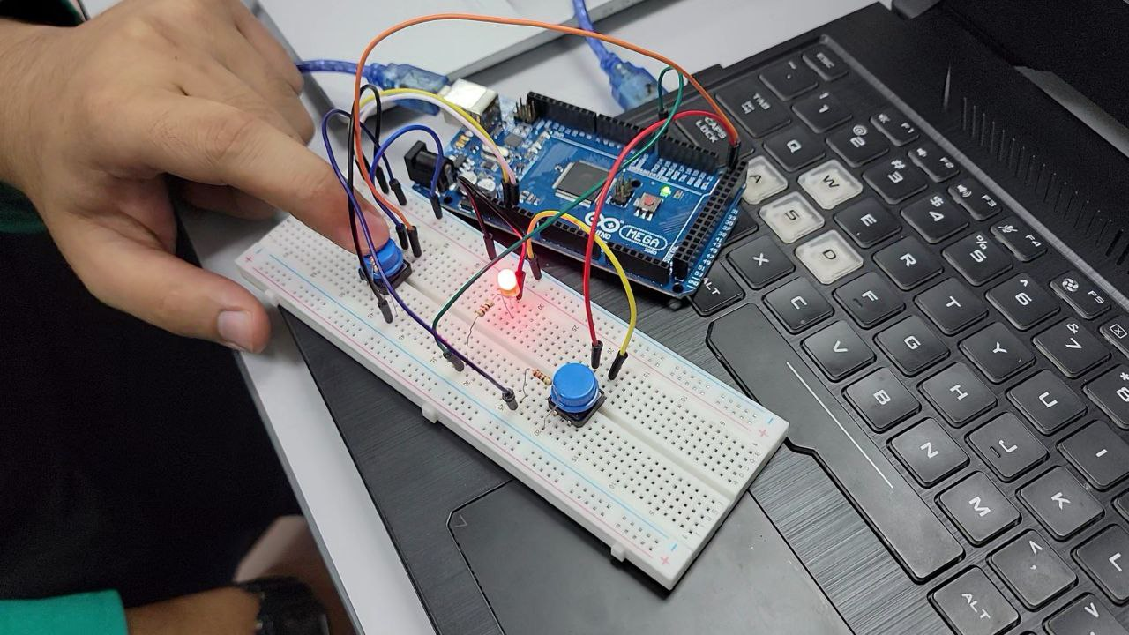

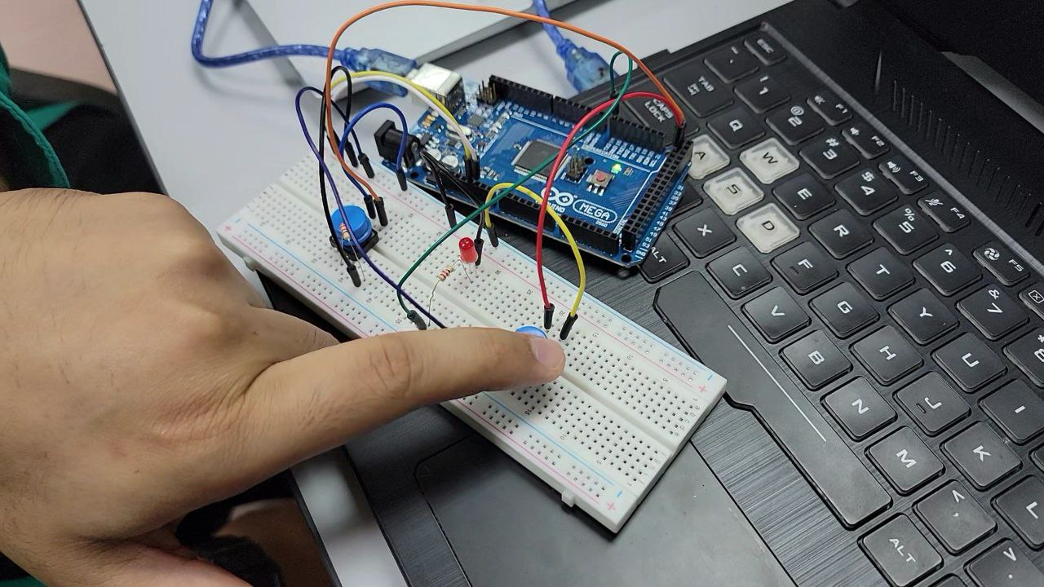

## **Discussion**

The experiment illustrated the fundamental principles of ladder logic and relay logic commonly employed in industrial control systems. The use of a holding contact ensured the LED’s continuous operation after the start button was released until the stop button was pressed.

For the start and stop control idea to be applicable in a variety of industrial applications, its scalability must be taken into consideration. While scalability entails expanding the ideas to suit increasingly complex systems with various components and varied control requirements, this experiment focuses on a simple control circuit with a single LED. Evaluating how well the ladder logic fits into more complex, networked systems demonstrates how flexible the control idea is. Deploying control solutions across a range of industrial processes requires scalability because it enables standardized and modular techniques that can be effectively incorporated into intricate automation frameworks, lowering total implementation costs and boosting flexibility.

## **Conclusion**

In conclusion, this experiment has demonstrated the integrated application of a start and stop control circuit using a ladder diagram on OpenPLC software, exhibiting one of its purposes in industrial automation. The circuit, specifically constructed to control an LED, has shown a consistent response with every press of the On and Off buttons. The On button is able to latch a connected circuit and results that the LED remains lighted, until Off button is pressed and engaged hence executing an open circuit in the breadboard.

The experiment has also highlighted some important features in demand of an electronic integrated circuit such as response time and feedback mechanisms. A fast response time was shown, indicating the circuit's reliability for real-time control applications. Some timers are also used in earlier experiments to exhibit how timers work in OpenPLC software which the user can preset according to the outcome of the experiment. A short duration of timer is often used to show how the software executes every bit of data received in real time. As we can see the push buttons are working as it is required and it shows the integrated feedback system between Arduino, circuit and software are working successfully.

Furthermore, the experiment has clearly executed and demonstrated the start and stop control for a more complex industrial scenarios. The nature of ladder diagram allows for the multiple integrated components and how the control logic can be expanded, hence providing a versatile outcome for more advanced automation solutions.

All in all, the implementation of the start and stop control circuit with an LED can be seen as quite a success. This has also helped junior engineers to observe the benefits of integrating OpenPlc software in the making of various integrated systems for a circuit.. The outcome gained from this experiment has given a foundation for further application of programmable logic controllers (PLCs) in various industrial settings.

## **Recommendations**

Improvements that can be done from this experiment is by experimenting with an increasing number of components that can be integrated and connected in our ladder system.

By adding more components such as multiple LEDs, switches, resistors and servo motors, we could observe and extend the versatility of our programmable codes and create a much more complex system that can reflect with the modern or in real life applications throughout our daily life such as traffic light simulators or pedestrian lights

Other than that, we can try to simulate a more complex system and circuit in the PLC software by looking for examples of advanced PLC applications. Some of the systems that we should try to integrate is an Automated Manufacturing System which the PLC is programmed to control automated assembly lines, robotic arms, and material handling.

Another example of advanced PLC application is by simulating a Water Treatment Plants in which the PLC controls the water supply , pumps and valves which implement predictive maintenance algorithms and optimizing the usage of water treatment processes.

## 

## **References**

<https://autonomylogic.com/docs/2-4-physical-addressing/>

## **Appendices**

### Code Snippets



### Circuit Diagram



# 

# **Student's Declaration**

**Certificate of Originality and Authenticity**

This is to certify that we are responsible for the work submitted in this report, that the original work is our own except as specified in the references and acknowledgement, and that the original work contained herein have not been untaken or done by unspecified sources or persons.

We hereby certify that this report has not been done by only one individual and all of us have contributed to the report. The length of contribution to the reports by each individual is noted within this certificate.

We also hereby certify that we have read and understand the content of the total report and no further improvement on the reports is needed from any of the individual’s contributors to the report.

We therefore, agreed unanimously that this report shall be submitted for marking and this final printed report has been verified by us.

Signature: Naufal Read

Name: Naufal Understand

Matric Number: 2110333 Agree

Contribution: Testing and Debugging

Signature: Aiman Read

Name: Aiman Understand

Matric Number: 2113571 Agree

Contribution : Programming

Signature: Nabil Read

Name: Nabil Understand

Matric Number: 2114577 Agree

Contribution: Circuit Design

Signature: Zakwan Read

Name: Zakwan Understand

Matric Number: 2111033 Agree

Contribution: Data Analysis

Signature: Che Read

Name: Che Understand

Matric Number: 21119075 Agree

Contribution : Discussion